Daily Check Schedule for E-learning
_______ wake up and eat breakfast

_______stretch and get ready to learn 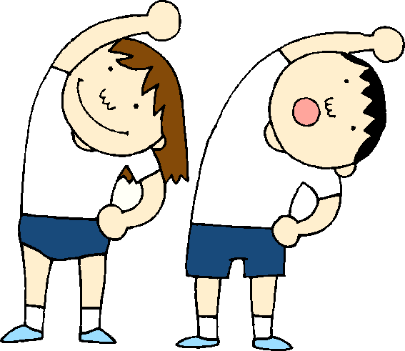

_______Writing for 30 minutes

________ Break for 45 minutes
Options: art activity, music activity, library, computer programs like mathseeds, scholastic, or razkids, or go outside for some gym time

_______Reading for 45 minutes
This can include your 20 minutes of independent reading along with your packet pages.
It also includes word work and spelling
______Lunch break for an hour
This can include eating and then having a short break as well.

_____Math for 45 minutes 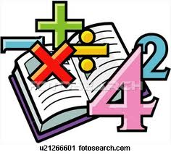

Options for break time:
https://app.gonoodle.com/
https://www.youtube.com/user/CosmicKidsYoga
https://www.washingtonian.com/2020/03/30/captain-underpants-dav-pilkey-drawing-classes-library-of-congress/
https://docs.google.com/document/d/1OH-_GM-eYefOa7JDNmM6wdUb9fsa1H8k8O_XgPih4m0/mobilebasic
https://www.kennedy-center.org/education/mo-willems/

